**EAST WEST UINVERSITY**

**Department of Computer Science and Engineering**

**Post Lab**

**Semester:** Summer’17

**Course code:** CSE 251 (2)

**Course title:** Electronic Circuits

**Experiment No:** 05

**Experiment title:** Signal Integration and Differentiation Using 741 Op-Amp

**Submitted to:**

Surajit Das Barman

Senior Lecturer

Department of CSE

East West University

**Submitted by:**

Kowser Mahmud Tanim

ID: 2015-2-60-062

Group No: 05

Group IDs: 2015-2-60-078, 2015-2-60-057, 2015-2-60-108

**Date of performance:** 18/07/2017

**Date of report submission:** 09/08/2017

**Experiment No:** 05

**Experiment Title:** Signal Integration and Differentiation Using 741 Op-Amp

**Objectives:**

1. To study the responses of Op-Amp integrator to sinusoid and square waveforms.
2. To study the responses of Op-Amp differentiator to sinusoid and triangular waveforms.

**Circuit Diagram:**



Figure 1: An Op-Amp integrator circuit



Figure 2: An Op-Amp differentiator circuit

**Equipment:**

1. Digital trainer board
2. Signal generator
3. Oscilloscope
4. Digital multimeter
5. 741 Op Amp (1 pc)
6. Resistor (1KΩ 1 pc)
7. Capacitor (0.1µF, 1 pc)
8. Breadboard
9. Connecting wires

**Post-lab Questions:**

**Integrator:**

1. Here,

Measured Value, R=1.02KΩ

Given Values, C= 0.1µF

= 0.1 $×{10}^{-6}$ F

VP =1V

Calculated Value, f=795.77Hz

We know, Amplitude, VO =

=

=

= 1.960V

Comparison between the Calculated & Measured value of the amplitude of output signal:

|  |  |  |
| --- | --- | --- |
|  | Calculated Value (V) | Measured Value (V) |
| Amplitude | 1.960 | 3.64 |

Both experimental and pre-lab measures are different.

1. Here,

f=795.71Hz

∆t = 340× 10^-6 s   
Phase difference, ө = 360∆t  
 = 360340 × 10^-6 × 795.71

= 89.41 $⁰$

Comparison between the Pre-lab & Measured values of the phase difference:

|  |  |  |
| --- | --- | --- |
|  | Pre-lab Value (V) | Measured Value (V) |
| Phase difference | 90 $⁰$ | 97.04 $⁰$ |

Pre-lab measure and experimental measure of phase relation are almost same.

1. Measured value of R = 1.02 KΩ

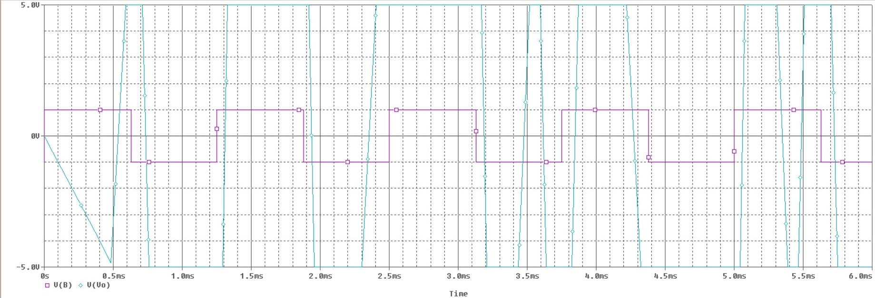

**Differentiator:**

1. Here,

Measured Value, R=1.02KΩ

Given Values, C= 0.1µF

= 0.1 $×{ 10}^{-6}$ F

VP =1V

Calculated Value, f=795.77Hz

We know, Amplitude, VO= VP RC ω

= 1×1.02×10^3×0.1×10^-6×5000

= 0.51V

Comparison between the Calculated & Measured value of the amplitude of output signal:

|  |  |  |
| --- | --- | --- |
|  | Calculated Value (V) | Measured Value (V) |
| Amplitude | 0.51 | 3.2 |

Both experimental and pre-lab measures are different.

1. Here,

f=795.77Hz

∆t = 340× 10^-6 s   
Phase difference, ө = 360∆t  
 = 360340 × 10^-6 × 795.71

= 97.41 $⁰$

Comparison between the Pre-lab & Measured values of the phase difference:

|  |  |  |
| --- | --- | --- |
|  | Pre-lab Value (V) | Measured Value (V) |
| Phase difference | 90 $⁰$ | 96.92 $⁰$ |

Pre-lab measure and experimental measure of phase relation are almost same.

1. Measured value of R = 1.02 KΩ

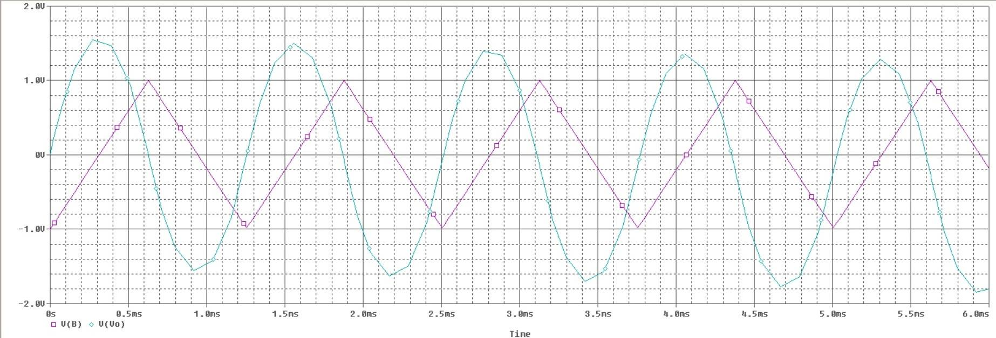

**Conclusion:**

In this experiment, both signal integration and differentiation have different measurements when using 741op-Amp. PSPICE was used for square and triangular wave input.